

**SUMMER TRAINING ON BIG DATA ANALYTICS**

**FOR THE WEEK COMMENCING : 01ST JUNE , 2018**

**NAME : *KUNAL BAISHKEYAR***

**Program : *B.TECH (COMPUTER SCIENCE & ENGINEERING)***

**Company Name : *INSANALYTICS – ANALYTICS TRAINING KOLKATA***

**Industry Guide’s Name : *Mr. ANKIT SHAW***

**Project Title: *ACCIDENT ANALYSIS PROJECT***



**ACKNOWLEDGEMENT**

It's a great pleasure to present this report of summer training in ***InsAnalytics , Kolkata*** in partial fulfilment of **B.Tech (COMPUTER SCIENCE & ENGINEERING)** Programme under **Amity Schools Of Engineering** Of **Amity University, Kolkata** . At the outset, I would like to express my immense gratitude to my training guide , **Mr. Ankit Shaw Sir,** guiding me right from the inception till the successful completion of the training . Also I would Like to pay thanks to other teaching staff and also to the Senior Mentor , **Mr.Goutam Das Sir** . I am falling short of words for expressing my feelings of gratitude towards him for extending their valuable guidance about Big Data Training and knowledge . I would also like to thank all my group members for their help and cooperation throughout the training.



1. **Data Sets**
2. **Accidents Data (1979-2013)**
3. **Casualties (1979-2013)**
4. **Models (1979 – 2013)**
5. **Prerequisite**
6. **Components used**
7. **Objective**
8. **Conclusion**
9. **Project Flow :**
10. **Phase 1 :**

* **Create the tables of Accidents , Casualties , Models .**
* **Load the data into those tables from the respective .csv files .**

1. **Phase 2 :**

* **Create 11 sub-tables for map joining with the major tables with the names:**

1. **age_band**
2. **cas_class**
3. **cas_sex**
4. **dow**
5. **driver_sex**
6. **light_cond**
7. **road_surface**
8. **road_type**
9. **severity**
10. **skid_overturned**
11. **weather_cond**

* **Load the data into sub-tables from the respective .txt files .**

1. **Phase 3 :**

* **Create permanent tables data loaded into it through temporary tables (temp) in each case and joined from major tables Accidents , Casualties and Models and 11 sub-tables :**

1. **acc_ageband**
2. **acc_casclass**
3. **acc_cassex**
4. **acc_dow**
5. **acc_driversex**
6. **acc_daylight**
7. **acc_roadsurface**
8. **acc_roadtype**
9. **acc_severity**
10. **acc_skid**
11. **acc_weather**
12. **Phase 4 :**

* **Import all the saved data through sqoop making another table in MySql :**

1. **cassex**
2. **casclass**
3. **ageband**
4. **dow**
5. **driversex**
6. **daylight**
7. **road surface**
8. **road type**
9. **severity**
10. **skid**
11. **weather**
12. **Phase 5 :**

* **Use MySql to query all the tables and to get the possible data .**

1. **Data Sets :**

* These files provide detailed road safety data about the circumstances of personal injury road accidents from 1979 -2013

* Following data files are present in this dataset:

1. **Accidents Data (1979-2013) :**

This data set consists of around 30 columns and around 78 lac rows . We have picked few columns like:

• Accident index

• Road type

• Road surface

• Severity

• Light conditions

• Days of the week ……. And so on .

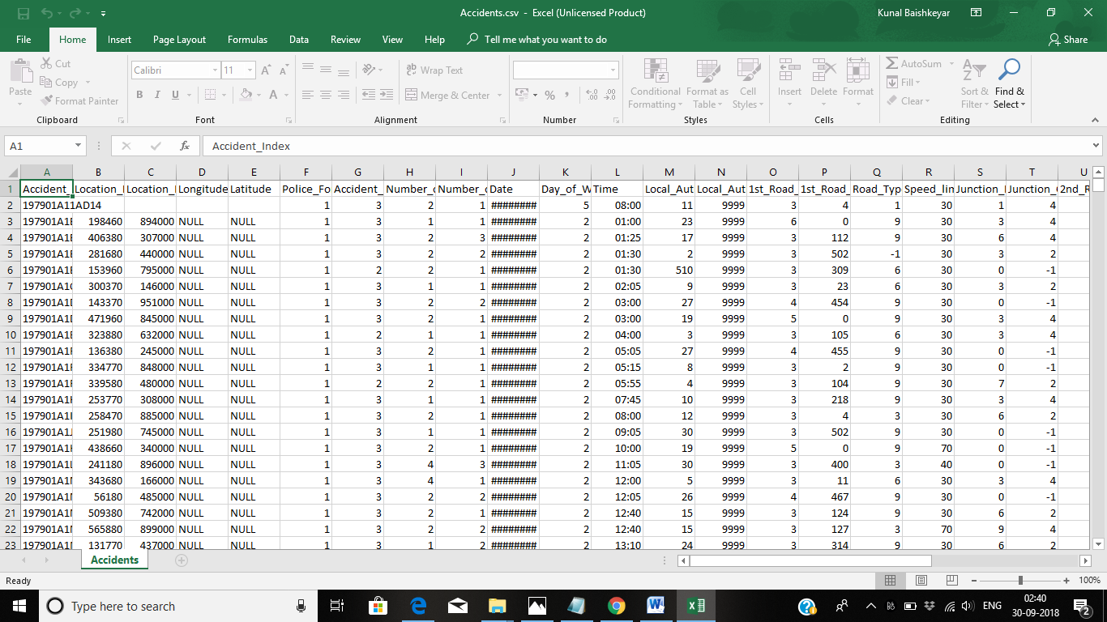

1. **Casualties Data (1979-2013) :**

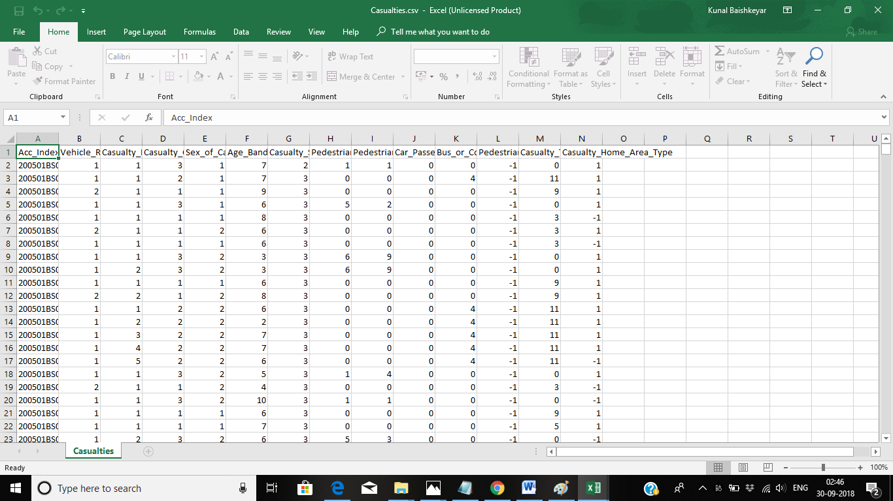

1. **Models Data (1979-2013) :**

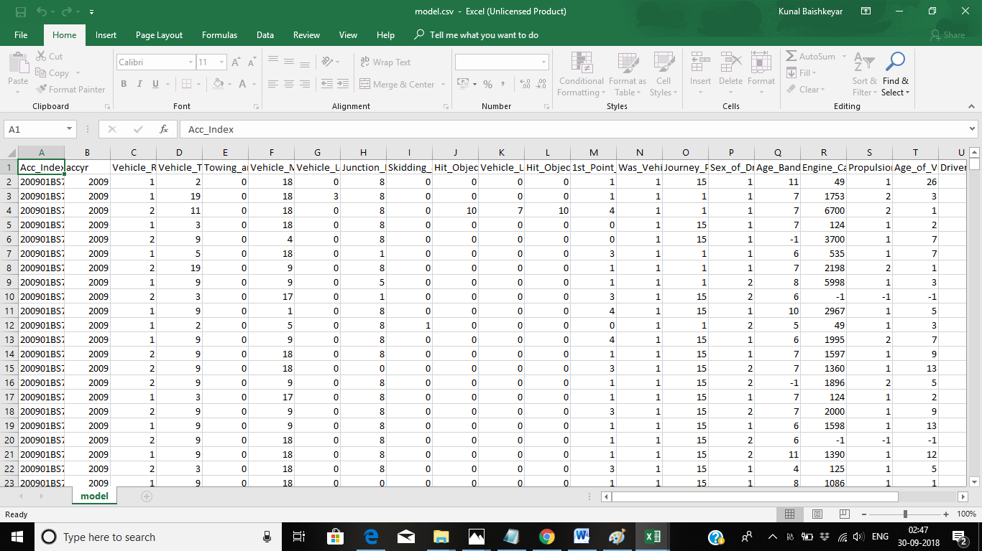

1. **Prerequisite :**
2. **Hadoop framework**
3. **Map-reduce**
4. **Pig**
5. **Flume**
6. **Sqoop**
7. **jsp/servlet**
8. **Data warehousing concepts**

1. **Components used :**
2. **Hadoop framework**
3. **HDFS**
4. **Hive**
5. **Map-reduce**
6. **Sqoop**
7. **Mysql**
8. **Objective :**

**To find the number of accidents happened:**

1. **in various weather conditions**
2. **in various light conditions**
3. **in various road surface conditions**
4. **in various road type conditions**
5. **during various days of week**
6. **on various skid and overturning**
7. **on various age band**
8. **due to difference in casualty sex**
9. **various types of Severity**
10. **Number of accidents happening due to difference in driver sex**
11. **Number of accidents happening due to difference in casualty class**
12. **Conclusion :**

**By using above data we can predict and make some decision to:**

* **Reduce accidents under the circumstances where more no. Of accidents are happening**
* **We can put up some kind of sign boards or make people aware of such circumstances so that they may be alert in such conditions**

1. **Project Flow :**
2. **Phase 1 :**

* **Create the tables of Accidents , Casualties , Models :**

**CREATE TABLE Accidents (Accident_Index string,Location_Easting_OSGR string,Location_Northing_OSGR string,Longitude string,Latitude string,Police_Force string,Accident_Severity string,Number_of_Vehicles string,Number_of_Casualties string,Dated string,Day_of_Week string,Time string,Local_Authority_District string,Local_Authority_Highway string,1st_Road_Class string,1st_Road_Number string,Road_Type string,Speed_limit string,Junction_Detail string,Junction_Control string,2nd_Road_Class string,2nd_Road_Number string,Pedestrian_Crossing_Human_Control string,Pedestrian_Crossing_Physical_Facilities string,Light_Conditions string,Weather_Conditions string,Road_Surface_Conditions string,Special_Conditions_at_Site string,Carriageway_Hazards string,Urban_or_Rural_Area string,Did_Police_Officer_Attend_Scene_of_Accident string, LSOA_of_Accident_Location string) ROW FORMAT DELIMITED FIELDS TERMINATED BY ',';**

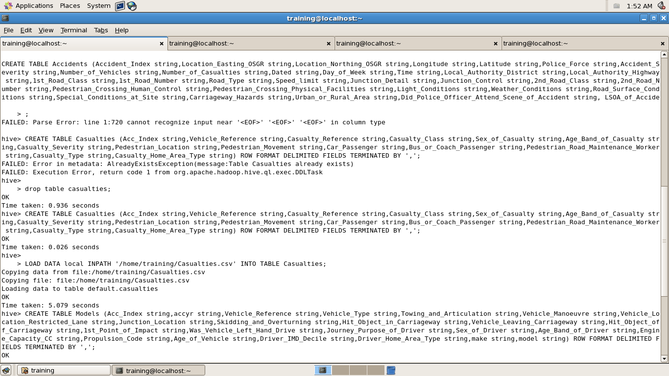

**CREATE TABLE Casualties (Acc_Index string,Vehicle_Reference string,Casualty_Reference string,Casualty_Class string,Sex_of_Casualty string,Age_Band_of_Casualty string,Casualty_Severity string,Pedestrian_Location string,Pedestrian_Movement string,Car_Passenger string,Bus_or_Coach_Passenger string,Pedestrian_Road_Maintenance_Worker string,Casualty_Type string,Casualty_Home_Area_Type string) ROW FORMAT DELIMITED FIELDS TERMINATED BY ',';**

**CREATE TABLE Model (Acc_Index string,accyr string,Vehicle_Reference string,Vehicle_Type string,Towing_and_Articulation string,Vehicle_Manoeuvre string,Vehicle_Location_Restricted_Lane string,Junction_Location string,Skidding_and_Overturning string,Hit_Object_in_Carriageway string,Vehicle_Leaving_Carriageway string,Hit_Object_off_Carriageway string,1st_Point_of_Impact string,Was_Vehicle_Left_Hand_Drive string,Journey_Purpose_of_Driver string,Sex_of_Driver string,Age_Band_of_Driver string,Engine_Capacity_CC string,Propulsion_Code string,Age_of_Vehicle string,Driver_IMD_Decile string,Driver_Home_Area_Type string,make string,model string) ROW FORMAT DELIMITED FIELDS TERMINATED BY ',';**

* **Load the data into that tables from the respective .csv files :**

**LOAD DATA local INPATH '/home/training/Accidents.csv' INTO TABLE Accidents**

**LOAD DATA local INPATH '/home/training/Casualties.csv' INTO TABLE Casualties**

**LOAD DATA local INPATH '/home/training/Model.csv' INTO TABLE Model**

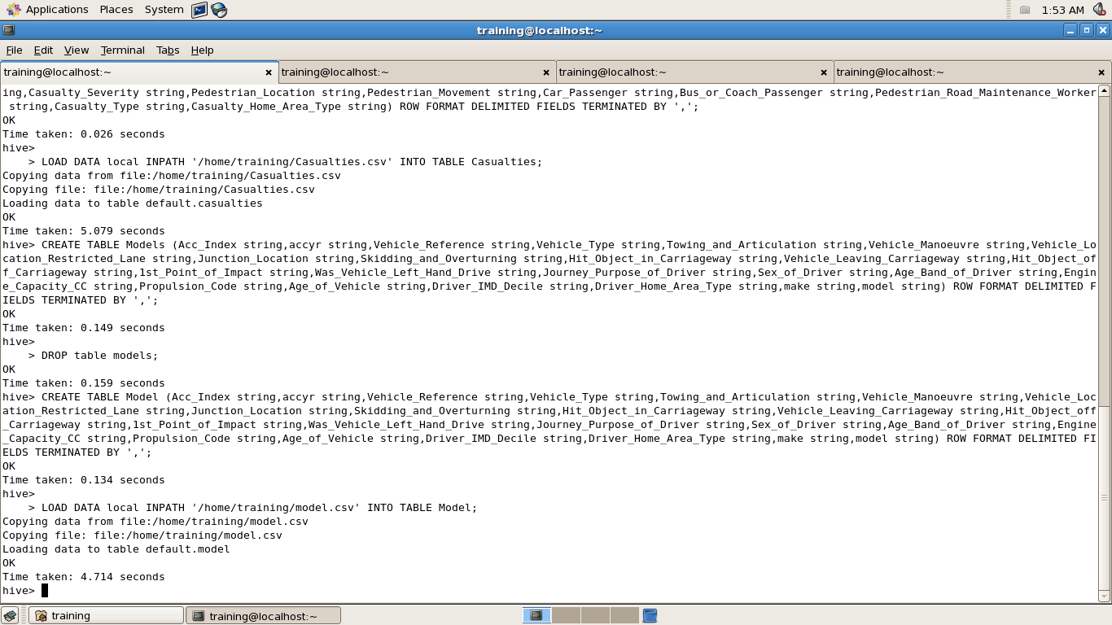

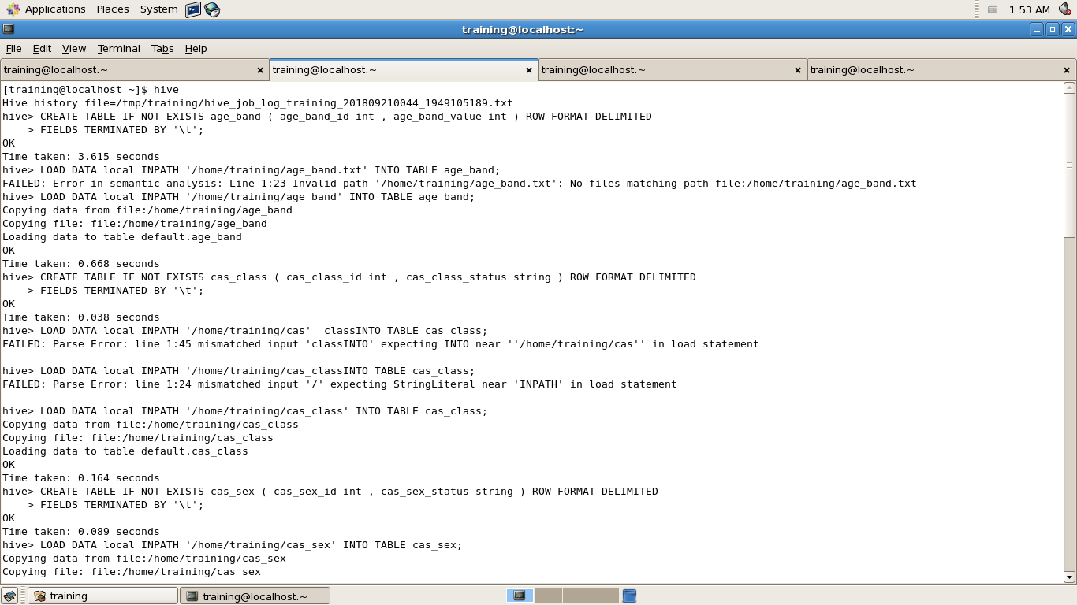

1. **Phase 2 :**

**Create 11 sub-tables for map joining with the major tables with the names:**

**Load the data into sub-tables from the respective .txt files .**

* **age_band :**

**CREATE TABLE IF NOT EXISTS age_band ( age_band_id int , age_band_value int ) ROW FORMAT DELIMITED FIELDS TERMINATED BY '\t' location '/user/training/age_band/'**

**LOAD DATA local INPATH '/home/training/age_band.txt' INTO TABLE age_band;**

* **cas_class**

**CREATE TABLE IF NOT EXISTS cas_class ( cas_class_id int , cas_class_status string ) ROW FORMAT DELIMITED FIELDS TERMINATED BY '\t' location '/user/training/cas_class/'**

**LOAD DATA local INPATH '/home/training/cas_class' INTO TABLE cas_class;**

* **cas_sex**

**CREATE TABLE IF NOT EXISTS cas_sex ( cas_sex_id int , cas_sex_status string ) ROW FORMAT DELIMITED FIELDS TERMINATED BY '\t' location '/user/training/cas_sex/'**

**LOAD DATA local INPATH '/home/training/cas_sex' INTO TABLE cas_sex;**

* **dow**

**CREATE TABLE IF NOT EXISTS dow ( dow_id int , dow_status string ) ROW FORMAT DELIMITED FIELDS TERMINATED BY '\t' location '/user/training/dow/'**

**LOAD DATA local INPATH '/home/training/dow' INTO TABLE dow;**

* **driver_sex**

**CREATE TABLE IF NOT EXISTS driver_sex ( driver_sex_id int , driver_sex_status string ) ROW FORMAT DELIMITED FIELDS TERMINATED BY '\t' location '/user/training/driver_sex/'**

**LOAD DATA local INPATH '/home/training/driver_sex' INTO TABLE driver_sex;**

* **light_cond**

**CREATE TABLE IF NOT EXISTS light_cond ( light_cond_id int , light_cond_status string ) ROW FORMAT DELIMITED FIELDS TERMINATED BY '\t' location '/user/training/light_cond/'**

**LOAD DATA local INPATH '/home/training/light_cond' INTO TABLE light_cond;**

* **road_surface**

**CREATE TABLE IF NOT EXISTS road_surface ( road_surface_id int , road_surface_status string ) ROW FORMAT DELIMITED FIELDS TERMINATED BY '\t' location '/user/training/road_surface/'**

**LOAD DATA local INPATH '/home/training/road_surface' INTO TABLE road_surface;**

* **road_type**

**CREATE TABLE IF NOT EXISTS road_type ( road_type_id int , road_type_status string ) ROW FORMAT DELIMITED FIELDS TERMINATED BY '\t' location '/user/training/road_type/'**

**LOAD DATA local INPATH '/home/training/road_type' INTO TABLE road_type;**

* **severity**

**CREATE TABLE IF NOT EXISTS severity ( severity_id int , severity_status string ) ROW FORMAT DELIMITED FIELDS TERMINATED BY '\t' location '/user/training/severity/'**

**LOAD DATA local INPATH '/home/training/severity' INTO TABLE severity;**

* **skid_overturned**

**CREATE TABLE IF NOT EXISTS skid_overturned ( skid_overturned_id int , skid_overturned_status string ) ROW FORMAT DELIMITED FIELDS TERMINATED BY '\t' location '/user/training/skid_overturned/'**

**LOAD DATA local INPATH '/home/training/skid_overturned' INTO TABLE skid_overturned;**

* **weather_cond**

**CREATE TABLE IF NOT EXISTS weather_cond ( weather_cond_id int , weather_cond_status string ) ROW FORMAT DELIMITED FIELDS TERMINATED BY '\t' location '/user/training/weather_cond/'**

**LOAD DATA local INPATH '/home/training/weather_cond' INTO TABLE weather_cond;**



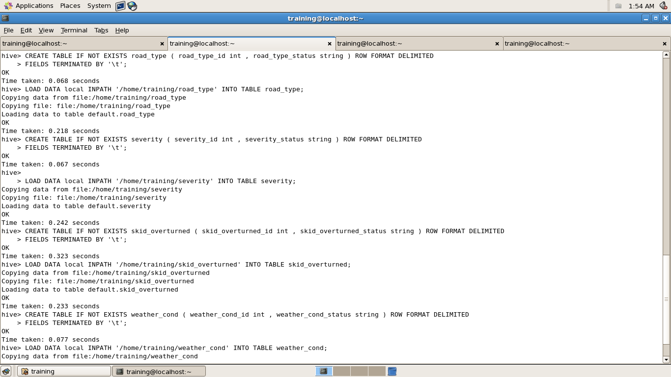

1. **Phase 3 :**

**Create permanent tables data loaded into it through temporary tables (temp) in each case and joined from major tables Accidents, Casualties and Models and 11 sub-tables :**

* **acc_ageband**

**select Age_Band_of_Casualty,count(acc_index) from casualties group by Age_Band_of_Casualty ;**

**create table temp(id int, cnt int) ROW FORMAT DELIMITED fields terminated by ',';**

**insert overwrite table temp select Age_Band_of_Casualty,count(acc_index) from casualties group by Age_Band_of_Casualty ;**

**select * from temp;**

**SELECT b.age_band_value,a.cnt from temp a JOIN age_band b ON (a.id = b.age_band_id);**

**create table acc_ageband (status string, cnt int) ROW FORMAT DELIMITED fields terminated by ',' ;**

**insert overwrite table acc_ageband SELECT b.age_band_value,a.cnt from temp a JOIN age_band b ON (a.id = b.age_band_id);**

**drop table temp;**

* **acc_casclass**

**select Casualty_Class,count(acc_index) from Casualties group by Casualty_Class ;**

**create table temp(id int, cnt int) ROW FORMAT DELIMITED fields terminated by ',';**

**insert overwrite table temp select Casualty_Class,count(acc_index) from Casualties group by Casualty_Class ;**

**select * from temp;**

**SELECT b.cas_class_status,a.cnt from temp a JOIN cas_class b ON (a.id = b.cas_class_id);**

**create table acc_casclass (status string, cnt int) ROW FORMAT DELIMITED fields terminated by ',' ;**

**insert overwrite table acc_casclass SELECT b.cas_class_status,a.cnt from temp a JOIN cas_class b ON (a.id = b.cas_class_id);**

**drop table temp;**

* **acc_cassex**

**select Sex_of_Casualty,count(acc_index) from Casualties group by Sex_of_Casualty ;**

**create table temp(id int, cnt int) ROW FORMAT DELIMITED fields terminated by ',';**

**insert overwrite table temp select Sex_of_Casualty,count(acc_index) from Casualties group by Sex_of_Casualty ;**

**select * from temp;**

**SELECT b.cas_sex_status,a.cnt from temp a JOIN cas_sex b ON (a.id = b.cas_sex_id);**

**create table acc_cassex (status string, cnt int) ROW FORMAT DELIMITED fields terminated by ',' ;**

**insert overwrite table acc_cassex SELECT b.cas_sex_status,a.cnt from temp a JOIN cas_sex b ON (a.id = b.cas_sex_id);**

**drop table temp;**

* **acc_dow**

**select Day_of_Week,count(accident_index) from Accidents group by Day_of_Week ;**

**create table temp(id int, cnt int) ROW FORMAT DELIMITED fields terminated by ',';**

**insert overwrite table temp select Day_of_Week,count(accident_index) from Accidents group by Day_of_Week ;**

**select * from temp;**

**SELECT b.dow_status,a.cnt from temp a JOIN dow b ON (a.id = b.dow_id);**

**create table acc_dow (status string, cnt int) ROW FORMAT DELIMITED fields terminated by ',' ;**

**insert overwrite table acc_dow SELECT b.dow_status,a.cnt from temp a JOIN dow b ON (a.id = b.dow_id);**

**drop table temp;**

* **acc_driversex**

**select Sex_of_Driver,count(acc_index) from Model group by Sex_of_Driver ;**

**create table temp(id int, cnt int) ROW FORMAT DELIMITED fields terminated by ',';**

**insert overwrite table temp select Sex_of_Driver,count(acc_index) from Model group by Sex_of_Driver ;**

**select * from temp;**

**SELECT b.driver_sex_status,a.cnt from temp a JOIN driver_sex b ON (a.id = b.driver_sex_id);**

**create table acc_driversex (status string, cnt int) ROW FORMAT DELIMITED fields terminated by ',' ;**

**insert overwrite table acc_driversex SELECT b.driver_sex_status,a.cnt from temp a JOIN driver_sex b ON (a.id = b.driver_sex_id);**

**drop table temp;**

* **acc_daylight**

**select Light_Conditions,count(accident_index) from Accidents group by Light_Conditions;**

**create table temp(id int, cnt int) ROW FORMAT DELIMITED fields terminated by ',';**

**insert overwrite table temp select Light_Conditions,count(accident_index) from Accidents group by Light_Conditions;**

**select * from temp;**

**SELECT b.light_cond_status,a.cnt from temp a JOIN light_cond b ON (a.id = b.light_cond_id);**

**create table acc_daylight (status string, cnt int) ROW FORMAT DELIMITED fields terminated by ',';**

**insert overwrite table acc_daylight SELECT b.light_cond_status,a.cnt from temp a JOIN light_cond b ON (a.id = b.light_cond_id);**

**drop table temp;**

* **acc_roadsurface**

**select Road_Surface_Conditions,count(accident_index) from Accidents group by Road_Surface_Conditions;**

**create table temp(id int, cnt int) ROW FORMAT DELIMITED fields terminated by ',';**

**insert overwrite table temp select Road_Surface_Conditions,count(accident_index) from Accidents group by Road_Surface_Conditions;**

**select * from temp;**

**SELECT b.road_surface_status,a.cnt from temp a JOIN road_surface b ON (a.id = b.road_surface_id);**

**create table acc_roadsurface (status string, cnt int) ROW FORMAT DELIMITED fields terminated by ',';**

**insert overwrite table acc_roadsurface SELECT b.road_surface_status,a.cnt from temp a JOIN road_surface b ON (a.id = b.road_surface_id);**

**drop table temp;**

* **acc_roadtype**

**select Road_Type,count(accident_index) from Accidents group by Road_Type ;**

**create table temp(id int, cnt int) ROW FORMAT DELIMITED fields terminated by ',';**

**insert overwrite table temp select Road_Type,count(accident_index) from Accidents group by Road_Type;**

**select * from temp;**

**SELECT b.road_type_status,a.cnt from temp a JOIN road_type b ON (a.id = b.road_type_id);**

**create table acc_roadtype (status string, cnt int) ROW FORMAT DELIMITED fields terminated by ',';**

**insert overwrite table acc_roadtype SELECT b.road_type_status,a.cnt from temp a JOIN road_type b ON (a.id = b.road_type_id);**

**drop table temp;**

* **acc_severity**

**select Casualty_Severity,count(acc_index) from Casualties group by Casualty_Severity ;**

**create table temp(id int, cnt int) ROW FORMAT DELIMITED fields terminated by ',';**

**insert overwrite table temp select Casualty_Severity,count(acc_index) from Casualties group by Casualty_Severity ;**

**select * from temp;**

**SELECT b.severity_status,a.cnt from temp a JOIN severity b ON (a.id = b.severity_id);**

**create table acc_severity (status string, cnt int) ROW FORMAT DELIMITED fields terminated by ',' ;**

**insert overwrite table acc_severity SELECT b.severity_status,a.cnt from temp a JOIN severity b ON (a.id = b.severity_id);**

**drop table temp;**

* **acc_skid**

**select Skidding_and_Overturning,count(acc_index) from Model group by Skidding_and_Overturning;**

**create table temp(id int, cnt int) ROW FORMAT DELIMITED fields terminated by ',';**

**insert overwrite table temp select Skidding_and_Overturning,count(acc_index) from Model group by Skidding_and_Overturning ;**

**select * from temp;**

**SELECT b.skid_overturned_status,a.cnt from temp a JOIN skid_overturned b ON (a.id = b.skid_overturned_id);**

**create table acc_skid (status string, cnt int) ROW FORMAT DELIMITED fields terminated by ',' ;**

**insert overwrite table acc_skid SELECT b.skid_overturned_status,a.cnt from temp a JOIN skid_overturned b ON (a.id = b.skid_overturned_id);**

**drop table temp;**

* **acc_weather**

**select Weather_Conditions,count(accident_index) from Accidents group by Weather_Conditions;**

**create table temp(id int, cnt int) ROW FORMAT DELIMITED fields terminated by ',';**

**insert overwrite table temp select Weather_Conditions,count(accident_index) from Accidents group by Weather_Conditions;**

**select * from temp;**

**SELECT b.weather_cond_status,a.cnt from temp a JOIN weather_cond b ON (a.id = b.weather_cond_id);**

**create table acc_weather (status string, cnt int) ROW FORMAT DELIMITED fields terminated by ',';**

**insert overwrite table acc_weather SELECT b.weather_cond_status,a.cnt from temp a JOIN weather_cond b ON (a.id = b.weather_cond_id);**

**drop table temp;**

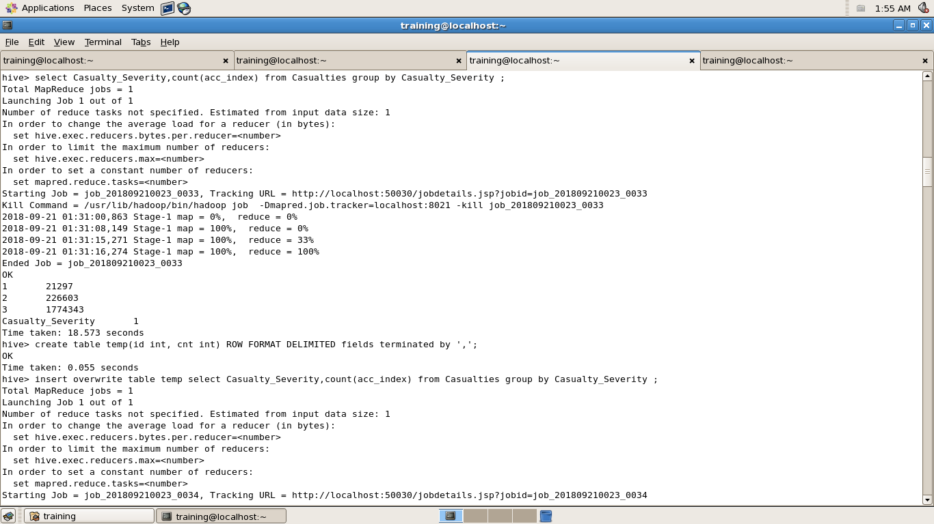

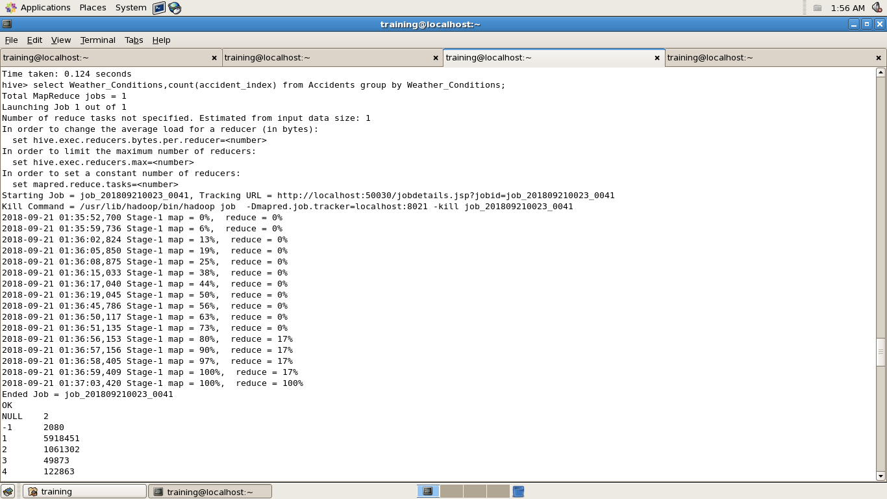

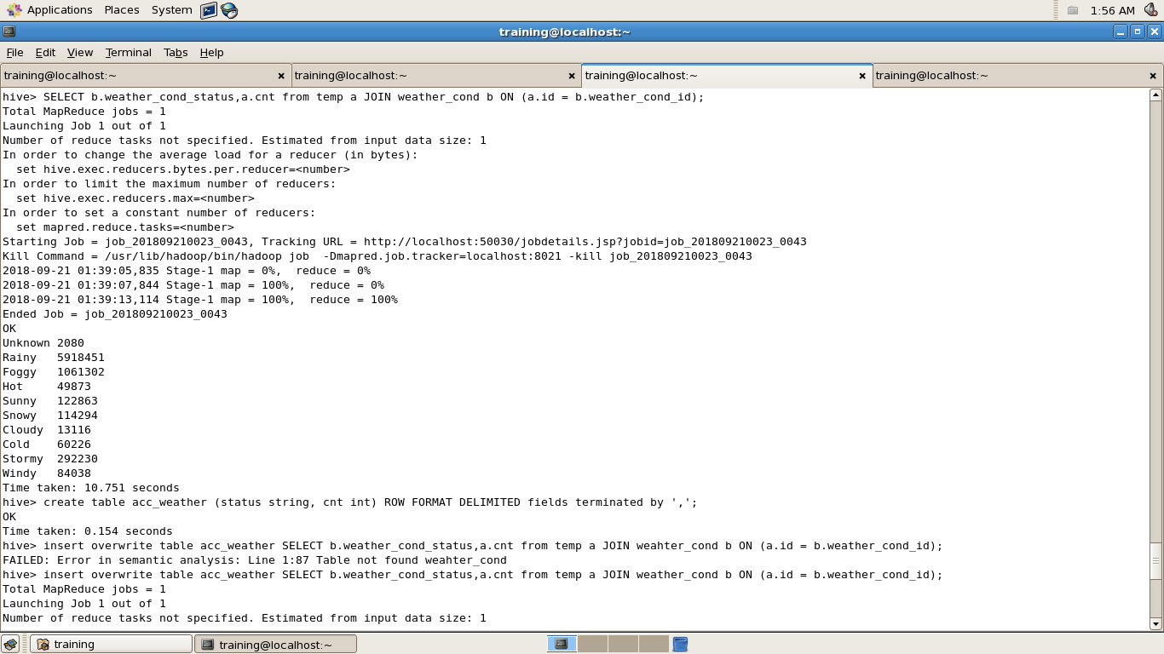

1. **Phase 4 :**

* **Import all the saved data through sqoop making another table in MySql :**
* **cassex :**

**CREATE TABLE cassex (cassex_type varchar(50) ,totalcount bigint);**

**sqoop export --connect jdbc:mysql://localhost/training --username training --password training --table cassex --export-dir /user/hive/warehouse/acc_cassex/**

* **casclass :**

**CREATE TABLE casclass (casclass_type varchar(50) ,totalcount bigint);**

**sqoop export --connect jdbc:mysql://localhost/training --username training --password training --table casclass --export-dir /user/hive/warehouse/acc_casclass/**

* **ageband :**

**CREATE TABLE ageband (ageband_status varchar(50) ,totalcount bigint);**

**sqoop export --connect jdbc:mysql://localhost/training --username training --password training --table ageband --export-dir /user/hive/warehouse/acc_ageband/**

* **dow :**

**CREATE TABLE dow (dowstatus varchar(50) ,totalcount bigint);**

**sqoop export --connect jdbc:mysql://localhost/training --username training --password training --table dow --export-dir /user/hive/warehouse/acc_dow/**

* **driversex :**

**CREATE TABLE driversex (driversex_status varchar(50) ,totalcount bigint);**

**sqoop export --connect jdbc:mysql://localhost/training --username training --password training --table driversex --export-dir /user/hive/warehouse/acc_driversex/**

* **daylight :**

**CREATE TABLE daylight (daylight_condition varchar(50) ,totalcount bigint);**

**sqoop export --connect jdbc:mysql://localhost/training --username training --password training --table daylight --export-dir /user/hive/warehouse/acc_daylight/**

* **roadsurface :**

**CREATE TABLE roadsurface (roadsurface_condition varchar(50) ,totalcount bigint);**

**sqoop export --connect jdbc:mysql://localhost/training --username training --password training --table roadsurface --export-dir /user/hive/warehouse/acc_roadsurface/**

* **roadtype :**

**CREATE TABLE roadtype (roadtype_status varchar(50) ,totalcount bigint);**

**sqoop export --connect jdbc:mysql://localhost/training --username training --password training --table roadtype --export-dir /user/hive/warehouse/acc_roadtype/**

* **severity :**

**CREATE TABLE severity (severitytype varchar(50) ,totalcount bigint);**

**sqoop export --connect jdbc:mysql://localhost/training --username training --password training --table severity --export-dir /user/hive/warehouse/acc_severity/**

* **skid :**

**CREATE TABLE skid (skidtype varchar(50) ,totalcount bigint);**

**sqoop export --connect jdbc:mysql://localhost/training --username training --password training --table skid --export-dir /user/hive/warehouse/acc_skid/**

* **weather :**

**CREATE TABLE weather (weathertype varchar(50) ,totalcount bigint);**

**sqoop export --connect jdbc:mysql://localhost/training --username training --password training --table weather --export-dir /user/hive/warehouse/acc_weather/**

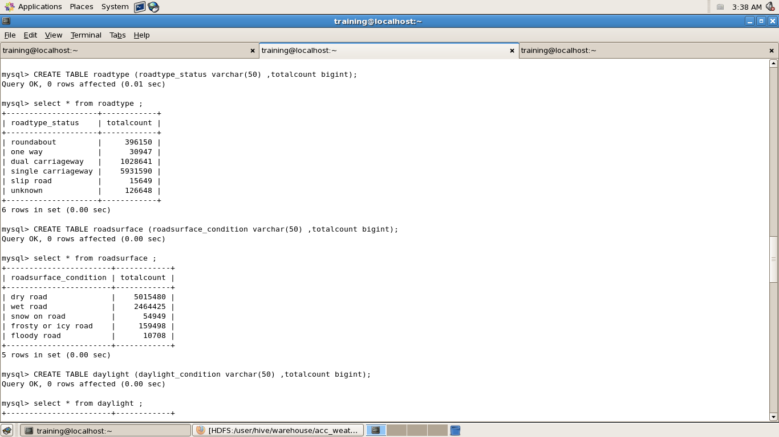

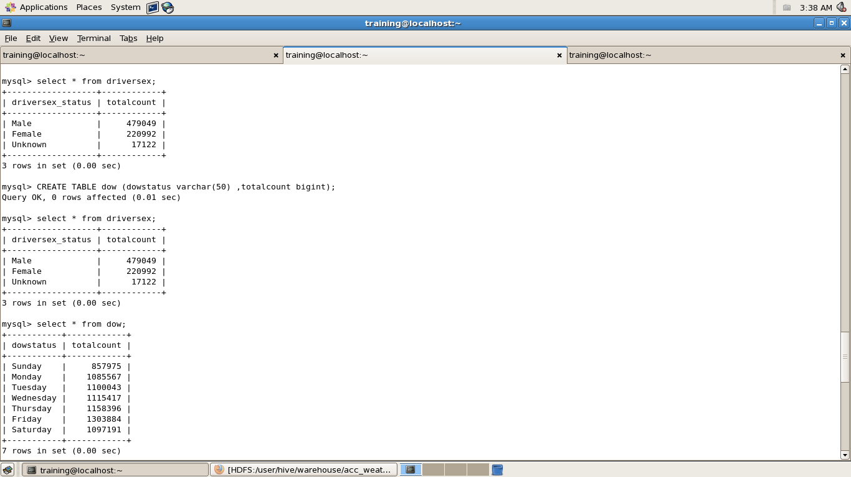

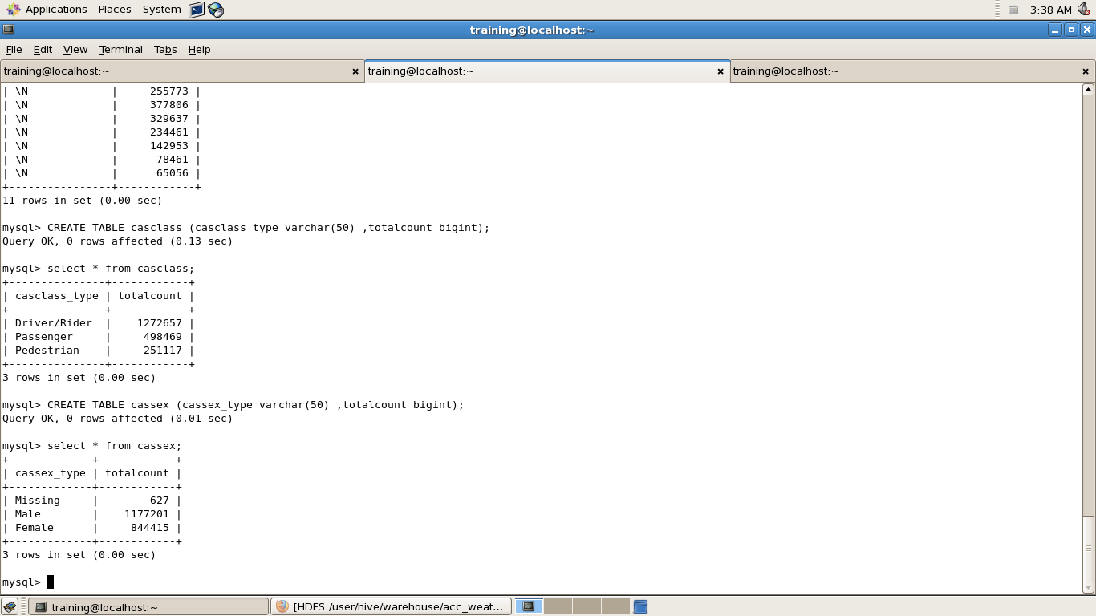

1. **Phase 5 :**

* **Use MySql to query all the tables and to get the possible data .**

**select * from weather ;**

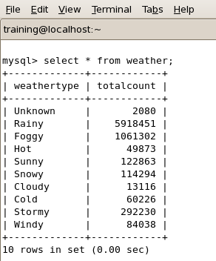

**select * from skid ;**

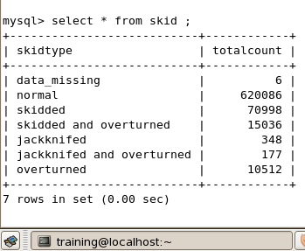

**select * from severity ;**

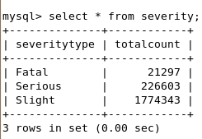

**select * from roadtype ;**

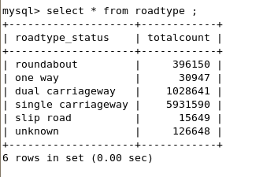

**select * from roadsurafce ;**

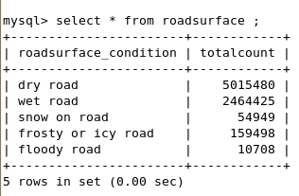

**select * from daylight ;**

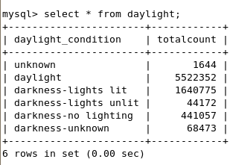

**select * from driversex ;**

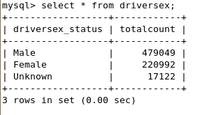

**select * from dow ;**

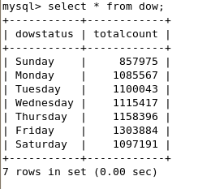

**select * from ageband ;**

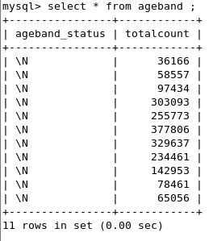

**select * from casclass ;**

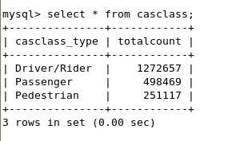

**select * from cassex ;**

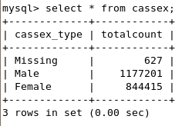



**After doing the project I came to the conclusion that the major accidents happened in the different circumstances . This are : weather conditions , skidding and overturned , severity conditions , road type conditions , road surface conditions , light conditions , sex of the driver , Day of week ,casualty sex , casualty class , age band .**

**Talking about the weather conditions , during the Raniy season the accidents happened the most .**

**Now talking about the skidding and overturned conditions the accidents happened the most when it the vehicle was at driving at normal speed .**

**Coming on the another reason for the major accidents to happen is severity type . The accidents happened the most when the severity type was Slight .**

**Another reason for the accidents to happen is the road type status . The major accidents happened when the road type status was Single Carriageway.**

**Another reason for the accidents to happen is road surface conditions . So when the road surface is dry that means major accidents happen when the road surface is Dry .**

**Another reason for the accident to occur is the light conditions . When it’s daylight the accidents happen the most .**

**Another reason for the accidents to be happened is the sex of the driver . So the maximum accidents happened when the sex of the driver is Male .**

**Another reason for the accidents is the day of the week on which day more accidents happened . So , the maximum accidents happened when the day of the week was Monday .**

**Another reason for the accidents to occur is the Casualty Class type . So , when the casualty class is Driver / Riding means they were riding single without carrying someone then the accidents happened the most .**

**Another reason for the accidents to occur the most is the Casualty Sex of the Driver . So when the Casualty Sex of the driver is MALE the accidents occurred the most .**

* **So at last I concluded my training by getting the actual reason for the major accidents to occur , and the reasons are different for different cases .**